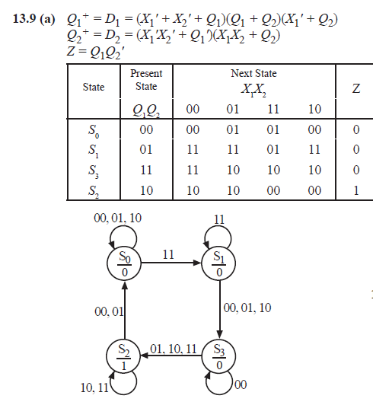

00

(1)

(2)

